St James Street Big Local Steering Group Meeting
Monday 7th September 2015 @ Harmony Hall
Attendees: Neesha, Linda, Libbi, Richard, Olly, Tom
Apologies: Fabien, Fiona, Wendy, Jamie A, Jamie C, Alan, Annemarie, Feroz, Betul, Tommy, Trevor,
Discussion points | Actions
Matters arising  - Alan and Neesha to meet to set up new budget.  - Alan to send on to Fabien and Fiona  - Neesha to send Doodle Poll  - Request for Olly to give Partnership Update  - Neesha to meet Councillor Waldron  - Neesha to add Richard/Business Forum updated to the next agenda | - Completed  - Unaware if this has happened  - Doodle poll was sent – the 7th was the most well attended day as agreed in August – however only 5 people attended.  - Completed at the meeting.  - See community worker update.  - Completed
Finance update  Alan was on holiday so a substitute finance update was show to indicate the receipt of the £9,600 ‘pathway funding’ into the bank. | Alan to submit up to date financial record before next meeting.
Jumble Trail Update:  The jumble trail will be this weekend. There are 62 signed up so far and we expect more by the end of the week as the take up has increased closer to the date. There has been mention of less visible displays this year by the wider public.  Many people have come into technical difficulty using the Jumble Trail website and are confused by the 2 step sign up process as well as how to locate their bird on the map. Neesha has been offering technical assistance to the public and noticed this has taken most of the time. It would useful to have a more user friendly site if we were to do it again.  Libbi and Jamie are setting up a Gardening stall in order to attract local people who are interested in Gardening and greening of spaces by community members. They have organised marketing material to highlight their connection to SJBL.  Tom suggests there by a mapping project of places people identify in terms of needing a bit of greening up. | Libbi to update the gardening details on Jumble Trail.  Neesha to give Libbi printed map of the area and signup sheets.
The Partnership  Olly describes the partnership briefly again to the group referring back to the information he had circulated a few months ago.  The partnership will supersede the current steering group and it will meet every 6 weeks. The main focus of the partnership will be to establish themselves as a group, planning and documenting the process of writing and spending the £1million.  4 new people have applied to be on the partnerships and interviews will take place next week.  Any current steering group members who want to go on to the Partnership group will be asked to respond via email completing the same questions and criteria as the new applicants.  In order for the partnership to formulate they need to document their process of finding members that meet the local trust criteria.  Criteria for the partnership: The partnership will need to be 8-10 people of which 51 % need to be local a residents. Overall we need to reflect of the areas demographics in a variety of ways set by the local trust.  Current Steering group members not wishing to be on the partnership but that would still like to be involved in the project will become part of a more operational group who meet quarterly. These may be members of ‘working groups’ who do not have as much time to give and/or those who feel their skills are more relevant to the operation rather than the planning of projects. | Olly Neesha and Linda to meet to discuss interview process.  PG 8 skills matrix produced post meeting at the meeting with O, N and L.  All – who want to apply should email me with their interest and I will send them the skills matrix and questions to complete.  All to think, approach people will help meet the criteria.
Phase 2 collecting wishes  2 new wish scoping documents have been completed and looked at during the meeting. They were circulated with the meeting notes prior to the meeting. Pages11-16  There are still 6 wishes to complete – these are divided in the group as all wishes need completing by the end of September.  Discussion about approaching the St James Neighbourhood Forum to complete a scoping document for wish ‘22’ – “Promote a strong community voice by supporting volunteers to establish a St James street community forum”.  Olly to complete wish ‘25’ – “Create information points” + ‘6’ “work with the community and partners to improve the safety and security of the area via soft methods”  Linda to complete wish ‘17’ by approaching the people she has already made contact with i.e. Tender, the outset and youth offending teams “ Big local Youth Panel”  A spreadsheet of the wishes and themes is presented in order that we could start to assess what is completed.  Together the group also look at overlapping themes and which can be put together decreasing the 29 ideas (page11+12) | Post meeting notes – Neesha met with Alison Griffin chair of the St James Neighbourhood Forum. Alison to complete scoping document and send back.  Olly  Linda  Neesha to update the sheet and circulate.  All wishes to be completed by end of September.
Business Forum update  Richard updated the group about the business forum. He has also produced a wish list item for the Business Forum – which when discussed it became apparent that this was not something we could support at the moment.  As an example of what the forum are doing they had written a petition to get the evening market, set to take place in the town centre, to come to the St James end of the market.  Another point of interest for the group would be to support a patrolling partnership to reduce crime and give a form of communications both to the police and between shops. It would be £10 per shop, per month – there are 22 potential businesses. Although we could not continually pay for something like this it could be an incentive, trail thing that we fund/match fund. | Richard to complete new scoping document.
Community Worker Update: pages 4-7  New work plan was discussed with the steering group to get input for this therefore arrived retrospective to the meeting but it is attached below in addition to the worker’s August update.  During the meeting it is agreed that Neesha will draft a Skelton plan for the October meeting based on the themes spread sheet and what information we have so far. | Neesha

Date and time of next meeting: Monday 19th October
Venue: Harmony Hall

August Community Worker Update
Meetings:
- Met with Linda to discuss ‘young people research’ – she has been doing lots of work and speaking to various people about ideas for what we could do to contribute to the area’s development for young people. So far her findings have been that there is actually a lot going on and already funded that we (the wider public) may not be aware of. It brought up an interested conversation about how ‘money’ alone is not the only thing we could be offering as part of our plan rather than double funding something for the sake of spending the money. Also that the information and research she has obtained is still vital in terms of explaining to the wider public why we have come to the final decisions we have in term of what we spend, where and why.

Partnership:
- Created newsletter containing advertisement of partnership places to mailing list via Mail Chimp.
- Advertised in various Facebook/twitter pages.
- Responded to applicants and compiled.
- 4 new applications have been received and circulated to the steering group to review at our next steering group meeting dated 7th September 2015.
Jumble Trail:
- 67 stalls have signed up so far.
- Created/supported none IT users to join the Jumble Trail, on-line, over the telephone and in person– came into some technical problems – did researcher found a new way of doing it.
- Lots of people have found the software hard to navigate, even those who have knowledge of IT software and consider themselves to be IT savvy. Therefore would consider a different platform for it to be more sustainable and work without the help of a dedicated worker
- Collated names, address on spreadsheet ready for promotional pack deliveries. Work with SJBL volunteers to do delivery.
- Laminated posted printed by Fiona and made up named packs ready for Fiona to collect from the Mill. More unnamed packs have been created in anticipation of new users.
- Will be attending the event and speak to new people about the SJBL.
Website:
- Updated Website ‘our story so far’ page using the Weebly programme
- Updated meeting dates up to 2016.
Wishes
- Supported 2 new applications; the Business Forum and Esther Neslen.
Esther Neslen – is a local artist who would be interested in working with young people in the area to restore a ghost sign tying into heritage and change. The desire to restore the ghost signs was highlighted during our consultation in February where 9 people specifically asked for that to happen in response to ‘Public Art’. She is also hoping to work with another local artist.
- Began creating an excel spreadsheet to compile the result of all 29 results.
- Looked at the William Morris Plan – need to discuss further with the PWG.
Previous Work plan March – July 2015:
What I was asked to do | What I did | What still needs to be done or altered in August to December
Taking the survey to outreach groups | Visited various groups or contact via phone as per monthly reports describe | Perhaps on going but not so vital
Plan, attend, Minutes/documents and meetings for SG + PWG | Attend first meeting – was asked not to attend next one and since then they seem to have lost momentum due to illness and other family/social things going.  - Spoke to various people to recruit them for members  - Met with local councillors and Ascham Homes.  - Sent out request/ advertised various places for new members – collected 4 new responses and replied to them. | Now we have new people interested in this group it needs to get going again.  - Interview process for new members  - Encourage the group to meet regularly and attend meetings.  - Support them to get documentation in place  - Help with research where necessary/requested.  - Work with them to start writing our plan.
Setting up a system for reporting on details of the 29 good ideas in the survey | - Have created a excel spreadsheet with all details in to be reviewed once PWG are in place. | - Receive input from steering group on improvements to the current format  - Create a qualifying
Support/admin to get 3 films made  - the Area Profile  - film 2  - film 3 | - There has no movement in this area. | - Unsure if this still wanted in the group – perhaps to raise at a meeting once we have the new members in place.
Admin for Jumbletrail | Completed as suggested above. | - Attend event  - Collate information for the website – update and upload  - Good news story post  - Suggestion of an easier platform as many people have struggled.
Public contact from the mobile or email account |  | - On going

Neesha’s Work Plan August to November 2015

Actions | To and in what order | Additional details | Time/ dates
Forming the PWG | Advertise for new members – compile and respond  Review applications  Interview new people  Identify skills gap and E&D  Sent to existing of steering group who might want to move over to the new group.  Ensure it meets Big Local criteria  Document process for transparency  Set meeting dates  Document model and working methods ie decision making  Sent to Big Local for approval | Interview dates set  Questions and skills matrix produced  All to complete the skills and E&D criteria  Elect positions  Memorandum of Understanding | August 2 days  September meeting 1 day  September ½ day  By End of September  September 1 day  October 2 days  To send off by end of October to hear back by November
Writing the plan | All wishes to be completed  Look for new input  Explain how these relate to our plan  Produce spreadsheet to compile and use as visual aid  Skeleton structure of a plan to be sent to the steering group by October meeting  Decide if we are going to write it or pay someone to write it? Or are we doing a film?  Draft plan written by  Support writer of the plan or write the plan  Submit Plan | Volunteers to be issued additional things to research and new people approached  This might have to happen several times and one2one basis in different ways.  Preliminary spreadsheet produced | August – September 2 days  August – September 1 day  At September meeting  September / October 2 days  At October meeting  At October meeting  November 2days  November/December 4 days  December 2015
General admin  - Updating website  - Sending out newsletters  - Attending / Minute steering meetings  - Attending / Minute PWG meetings  - Talking to the public and dealing with enquiries | Jumble trail update  Formed the partnership +documentation and heard back from big local – on website | Good news story created and put on the website | September 1 day  September/October and November 3 x 1 day  September/October 2 days  November newsletter ½ day  Ongoing ?

Please help us understand your best skills. Everyone has strengths and weaknesses and in order for our project to success we would like to have a good mix therefore please only circle the ones you feel you excel at.
My skills …………(insert name) ……..
Diplomatic | Assertive | Negotiator | Motivated
Accountancy | Empathy | Integrity | Team player
Reflective | Punctual | Charity | Decision maker
Technical | Diversity champion | Entrepreneur | Organised
Leadership | Ethical | Blue Sky Thinker | Analysing
Computer Fluent | Logical | Written Communicator | Project Management
Articulate | Interpersonal | Languages | Commercial awareness
Financial acumen | Independent | Flexible | Conflict Resolution
Creativity | Nurturer | Self-awareness | Verbal Communicator

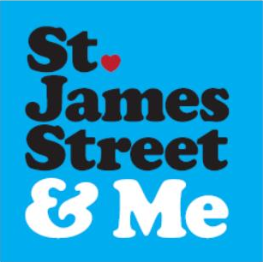
Action Plan: 29 Ideas Initial Scoping
Idea # -
By:
Date:

Our shared vision: ”St James Big Local's vision for the area in 2025 is that our diverse community will be living in a cleaner, greener, safer area with a reinvigorated local economy"
Most Relevant Comments from Phase I Survey

Stakeholders & Possible Partners Identified
(Attach meeting notes to this summary)

Summary of Possible Ideas for Action Plan
(What/When/Where/By Who?/For Who?)

Examples of Similar Type/Scale of Work by Other Community Groups
(Ideally London based so that we could possibly visit them. Include contact details.)

Suggested Future Monitoring Dates & Measurable Outcomes for Each Idea
(Consider short, medium and long term)

What Funding/Time Offered/Required by Stakeholders/Partners/Local Community

Approx Funding Required: £ Capital / Revenue / Loan
Approx Total Project Cost: £ (total inc match funds/time/BL cash)

Any additional Skills or Advice Required? Alternative Stakeholders/Partners?

Any alternative provision? Existing or proposed?

Next Steps

Action Plan: 29 Ideas Initial Scoping
Idea # 9) public art: mural using existing old adverts
By: Esther Neslen
Date: 5th September 2015

Our shared vision: ”St James Big Local's vision for the area in 2025 is that our diverse community will be living in a cleaner, greener, safer area with a reinvigorated local economy"
Most Relevant Comments from Phase I Survey
Improving the safety of the area using 'soft' methods, improving the street scape, public art, civic pride through activities and education and care for locality, support an established programme to help disadvantaged children, support youth work, promote volunteering, skills sharing and mentoring, regeneration
Stakeholders & Possible Partners Identified
(Attach meeting notes to this summary)
Forest Recycling Project – see correspondence below*
- Heritage Lottery Fund
- Outset Centre
- Local businesses
Summary of Possible Ideas for Action Plan
(What/When/Where/By Who?/For Who?)
Design and paint a mural incorporating the existing old advert on the side of 69 St James St – Weltree pharmacy (see pic01). The image will be devised (and possibly realised) collaboratively with young people involved with The Outset Centre. The process can start from the beginning of 2016. It will enhance the everyday experience of the whole community, and ideally lead to more murals involving the old adverts on the walls around St James St.
Examples of Similar Type/Scale of Work by Other Community Groups
(Ideally London based so that we could possibly visit them. Include contact details.)
Forest Recycling Project have been involved in many community mural projects. You can contact Nilesh on paint@frponline.org.uk

Suggested Future Monitoring Dates & Measurable Outcomes for Each Idea
(Consider short, medium and long term)
The young people involved in realising the mural can give feedback as it goes along. How successful the mural is could be incorporated into ongoing monitoring of the area, as well as looking at the media coverage it attracts.

What Funding/Time Offered/Required by Stakeholders/Partners/Local Community
Forest Recycling Project have offered paint for free. The Outset Centre would need to provide supervising adults, space and facilities to develop the ideas.

Approx Funding Required: £3,000 Capital
Approx Total Project Cost: £7,000 (total inc match funds/time/BL cash)
Any additional Skills or Advice Required? Alternative Stakeholders/Partners?
I'm keen to work with the Outset Centre staff to explore ways of engaging with young people. Local businesses could sponsor this project – maybe have their logo on the mural.

Any alternative provision? Existing or proposed?
This is the largest old advert on a wall in the St James St area. If the funds/permissions are not forthcoming the project could be scaled back to another smaller easier to reach option (see pics 02, 03 and 04). Indeed it should be possible to roll out this project to the other old ads in the area.
It would also be possible to work with different groups of young people through other organisations.

Next Steps
Contact Outset Centre. Get in touch with owner of 69 St James St.

Pic 01:
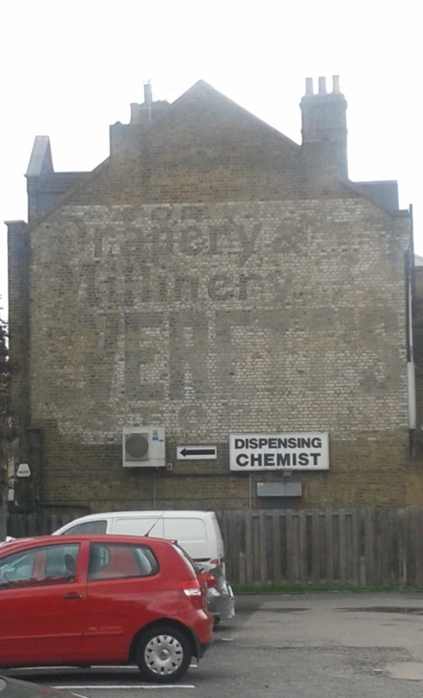

Pic 02: 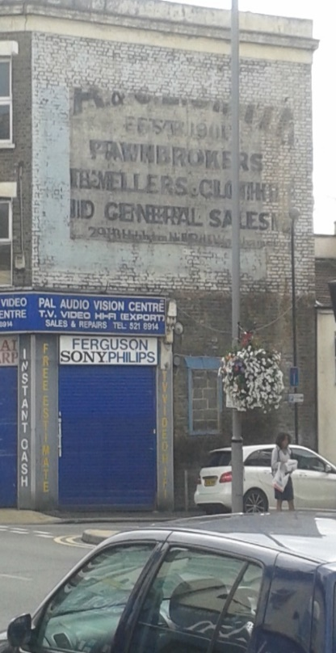

Pic 03:
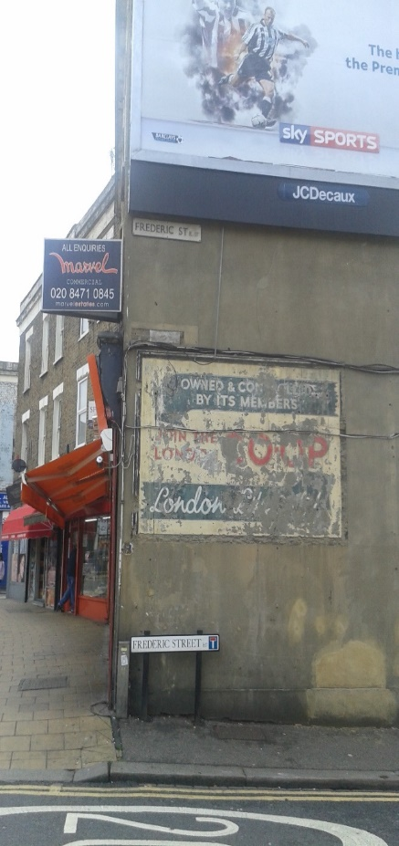
Pic 04:
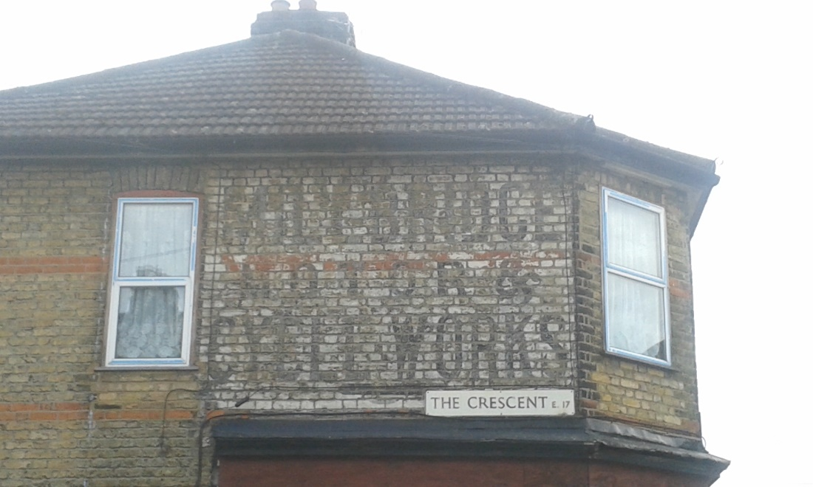

Action Plan: 29 Ideas Initial Scoping
Idea # Business Forum Idea

By: Richard Vials - Oxfam Walthamstow - St James St Business Forum
Date: 28/8/15

Our shared vision: ”St James Big Local's vision for the area in 2025 is that our diverse community will be living in a cleaner, greener, safer area with a reinvigorated local economy"

Most Relevant Comments from Phase I Survey
Local business demography - “promote and support business on the High Street & Market”)

Stakeholders & Possible Partners Identified
(Attach meeting notes to this summary)
Waltham Forest Council, Artillery, St James St Business Forum

Summary of Possible Ideas for Action Plan
(What/When/Where/By Who?/For Who?)
A special interest market extending from the High Street/Mission Grove junction up until the High Street/St James Street Junction. At least 1 full day a month, preferably Saturday, with 20-40 stalls. Alternative offer to Walthamstow Market with more emphasis on local artists and opportunities for local businesses to showcase their products/services

Examples of Similar Type/Scale of Work by Other Community Groups
(Ideally London based so that we could possibly visit them. Include contact details.)
“Love North Chingford Market”, set up by Stephen Murphy of North Chingford Business Forum:
https://www.facebook.com/pages/Love-North-Chingford/1461478190738292?sk=timeline&ref=page_internal

Suggested Future Monitoring Dates & Measurable Outcomes for Each Idea
(Consider short, medium and long term)
-1 month - no. of interested stallholders, net income for each stallholder
-3 months - no. of interested stallholders, net income for each stallholder
-1 year - no. of interested stallholders, net income for each stallholder

What Funding/Time Offered/Required by Stakeholders/Partners/Local Community
-Funding for Street Trading Licences for interested businesses/groups/artists
-Publicity (flyers, posters, notices, articles in local press)
-Coordination of stallholders by SJS Business Forum committee
-Market stall tables, gazebos, tarpaulins etc
Approx Funding Required: £ 8, 000 (if 20 stalls on a Friday for 1 year) Capital / Revenue / Loan
Approx Total Project Cost: £ 8, 000 (total inc match funds/time/BL cash)
Any additional Skills or Advice Required? Alternative Stakeholders/Partners?
-
Any alternative provision? Existing or proposed?
-
Next Steps
-Liaise with local businesses/artists/groups to gauge interest and find stallholders
-Discuss logistics with interested stallholders and develop business plans for their stall
-Contact council re: licencing and private markets

Volunteer | No | Wishes | Possible Partners |  | Theme | Target | quantity | cost | timescale | Overlaps with
Ingrid/Alison | 1 | Support the work of local volunteer-led community centre: The Mill | The Mil |  | People+ places
Fabien | 2 | Work to promote links with Walthamstow Marshes – both physical and visual |  |  | Places |  |  |  |  | and 9
Olly | 3 | Greening of Streets - new trees and planters in the public realm |  |  | Places |  |  |  |  | and 16
Fiona | 4 | Larger scale community events eg Jumble Trail, Festival, funfair etc |  |  | Events
Tommy/CREST | 5 | Support and activities for vulnerable elderly people eg. Befriending, shopping service etc. | CREST |  | People
Olly | 6 | Work with the community and other partners to improve the safety and security of the area via “soft” methods |  |  | People
Olly | 7 | Work with LBWF on the Heritage Lottery Bid to improve the shop fronts and St James Street street-scape |  |  | Places
Fiona | 8 | Work with the rail operators to improve the accessibility, appearance and lighting of St James Street station. | TFL |  | Places + Transport
Fabien, Jamie, Libbi | 9 | Public art |  |  | Places+ people
 | 10 | Promote the idea of civic pride through activities and education, to encourage local people to better care for the St James Street area |  |  | People + Education/Events |  |  |  |  | and 4
Linda | 11 | Support an established programme to help disadvantaged children improve behaviour, school attendance and academic results |  |  | People
Volunteer | No | Wishes | Possible Partners |  | Theme | Target | quantity | cost | timescale | Overlaps with
Fiona | 12 | Support a Community Café with an ethos of access for all and sustainable living (possibly with food recycling |  |  | Business+ people
Annemarie | 13 | Work with the St James Street Health Centre User Group to resolve the lease issues which are blocking improvements to their buildings |  |  | Places + people
Linda | 14 | Support Youth work and activities | Outset centre  Youth services  Tender |  | People
The Mill | 15 | Community Chest: Small grants programme to support local people to run events and community building activities | The Mill/CREST |  | Finance
Libbi and Jamie C | 16 | Promote a front gardens initiative (like that in Finsbury Park |  |  | Places
Linda | 17 | Big Local Youth Panel, with a dedicated activity plan and budget, within the larger St James Big Local | Tender |  | People
Libbi and Jamie C | 18 | Work with partners, including Groundwork London, to support “friends of parks” groups and support their community building activities. | Ground worker  Lea Valley  Local Housing Associations  LBWF |  | Places + People |  |  |  |  | 3 and 18
Richard/Betul | 19 | Work with partners to promote volunteering, skills sharing and mentoring to benefit St James Street residents and businesses | Oxfam |  | People + Business
Tommy/CREST | 20 | Support Activities for over 65 | CREST |  | People |  |  |  |  | and 5
Betul | 21 | Support for entrepreneurs and business start ups |  |  | Business
Volunteer | No | Wishes | Possible Partners |  | Theme | Target | quantity | cost | timescale | Overlaps with
Alison | 22 | Promote a strong community voice by supporting volunteers to establish a St James Street “community forum”, “area lobby group” or similar | SJNF |  | People
Fabien/Fiona | 23 | Work with LBWF on the Mini Holland proposals for traffic calming, street planting and cycle facilities | Mini  Holland LBWF |  | Places
Jamie A | 24 | Work with partners to promote energy efficiency and investigate the potential for community wide regeneration schemes. |  |  | Environment
Olly | 25 | Create information points – community noticeboards and online resources |  |  | Communication |  |  |  |  | 7 and 3
Betul + Richard | 26 | Work with partners to aid local businesses including support groups, help to get online and joint promotion of the local area | SJBF |  | Business
Neesha/Fiona | 27 | Support the work of local charity Crest – a key supporter of St James Big Local | CREST |  | People+ Places
Neesha + Jason | 28 | Work with partners, including the Credit Union, to provide financial education and promote alternatives to expensive High Street lenders | Credit Union |  | Finance
PWG | 29 | Work to make Big Local more transparent and inclusive | Big Local/Local Trust |  | Business
? | 30 | Support local homeless people | Christian kitchen |  | People

