St James Street Big Local Steering Group Meeting
Monday 2nd March 2015 7-9pm at La Mandache Restaurant
Attendees: Betul, Tommy, Fiona, Linda, Fabien, Wendy, Tom, Craig, Olly, Jamie C, Libbi
Invited Speakers: Chris Harrison of LBWF and Susan Williams of Vision On.
Apologies: Jamie A, Alan, Annemarie, Feroz, Neesha, Trevor
Discussion points | Actions
Introductions
Five new residents and the 2 invited speakers were welcomed to the meeting.

Matters arising  The main matters arising from 2nd February were picked up in the main agenda items. The following smaller matters were carried over to be discussed at the next meeting in April:  - Alan to issue this month’s financial update.  - Neesha & Trevor to confirm that the Pathway Funding and the Worker Contract Extension funding applications have been sent to Local Trust.  - Expressions of interest from film makers to be sought in relation to the Plan submissions to be made to Local Trust in July.  - Trevor to send sample codes of conduct to Jamie for the Partnership Working Group to consider  - Betul & Neesha to report back on the Business Training event on 18th Feb.  - Vision On to report back about whether room rental can be arranged at The Mill for the Business Forum. | Alan  Neesha/Trevor  Fiona/Neesha  Trevor  Betul/Neesha  Susan/Betul
Chris Harrison, Mini Holland  Chris gave an introduction to Mini Holland and described the likely progress of consultation work over the next 6 months or so. The project is aimed at improving walking and cycling facilities with the aim of reducing car journeys. About 40% of journeys in LBWF are of 3 miles or less, so a significant reduction in traffic could be made if walking and cycling was more pleasant. The Council are seeking information and views from local residents to build into their designs starting with a survey which will be delivered to all residents in the Blackhorse Rd area over the next 2-3 weeks (also online). Local residents and groups will be consulted at small meetings over the following 4-6 weeks, with another 4-6 weeks being spent to develop designs/”final plans”. The “final plans” will go to full public consultation either before or after the summer holidays in 2015, with the aim of work being carried out by the end of 2015/early 2016.  Chris asked the group to share the surveys across our contacts and social media to help spread the word, and also ask him back to a future meeting in a few months to discuss the developing proposals. Post meeting note – Fiona to ask whether Chris would want to return on 20th April or 1st June. | All  Fiona
Susan Williams – Vision On  Susan described the work that her company, Vision On, has been appointed to do by LBWF in connection with the Heritage Lottery Fund (HLF) shop front improvement scheme. Susan had been working with retailers and could see that their concerns tie in closely to the concerns captured in Big Local’s survey work. Vision On have worked on business support and with business forums in other shop front improvement schemes across the borough (eg Wood Street, Hoe Street and Bakers Arms amongst others). Susan began the process of setting up a forum for retailers in St James Street in December. The first meeting was attended by 20 businesses and it is hoped that over 30 will attend the next meeting in March. Susan asked the group if it would be possible for the Business Forum to:  - Use the Big Local Branding to help present a united identity for the area.  - Take over the Facebook business page started by Neesha last year  - Longer term become a working group to Big Local  - Be involved with events such as Jumble Trail and Market Events  These items were agreed by the group and Susan to liaise with Betul & Neesha as required. | Susan/Betul/ Neesha
Jumble Trail  Fiona updated the group following the discussion paper circulated with the agenda, which had outlined that development of a website to suit Big Local’s aims would have substantial costs whether we develop our own site or partner with the owners of Jumbletrail.com. It was agreed that there was not enough information to be able to decide to investing substantially in either option for a trail this year. It was discussed whether to run the event ourselves using a spreadsheet instead of a dedicated website but it was thought that this would take too much volunteer/worker time for the size of the event. It was agreed that worker time and a budget of up to £250 could be spent on another trail using Jumbletrail.com in August 2015. Neesha would be the main point of contact for the website this year and provide phone support as before. Fiona to investigate options for purchasing registrants emails from Jumbletrail and to report back on this and suggested dates for the event at the next meeting. | Fiona
Annual Review & Next Steps  A paper (attached) was circulated outlining our progress over the last 12 months and how the main visioning survey, and engagement, targets for the Getting Started period have been met. The next steps involve sending Neesha to do outreach with Stakeholder groups on the Phase II survey to help set priorities, while the Steering Group research the 29 “good ideas”. Volunteers came forward to research the following topics and report back at the next meeting:  - The Mill & Small Grants Programme – Jason  - Public Art & Visual Links to the Marshes – Fabien, Libbi & Jamie C  - HLF Work and Public Realm/Greening of Streets – Olly  - Soft measures to improve safety & security - Craig  - Network Rail & Station – Fiona  - Events inc Jumble Trail – Fiona / Tommy  - Support & activities for vulnerable elderly - Tommy  - St James Health Centre – Annemarie (post meeting note – Annemarie began this work back in 2014 so should continue. Wendy to chose a different topic).  - Support for disadvantaged children - Linda  - Work to support local businesses - Betul  Post meeting note:  Reports should be one side of A4, or less (or a simple description which can be recorded in the minutes). 'Reports' should ideally include some initial ideas/thoughts on how Big Local can get involved with activities, action or support. Identify key stakeholders and their contact details. Make contact with some or all of the stakeholders (if these are any of the local schools or housing associations please liaise with Neesha to go through existing lines of communication) to explore ideas and feasibility. Identify sources of match funding (could be time, resources or money) and any criteria/time limits. | Jason  Fabien/Libbi/Jamie  Olly  Craig  Fiona  Tommy  Annemarie  Linda  Betul
Partnership Working Group (PWG)  It was agreed that after something of a false start, that another meeting would be arranged to make a fresh start. Attendees should include Trevor, Jamie, Annemarie and other established members of the Steering Group who wish to join in, alongside Olly, Craig & Tom. Libbi also volunteered her experience through work as a management consultant. Olly agreed to arrange. | Olly
Community Worker Update  Neesha’s report was circulated to attendees before the meeting but no discussion took place. Neesha to update and issue a draft work plan by end of March 2015 for comment by the Steering Group.  The Steering Group to make suggestions about which stakeholders we should be sending Neesha out to talk to about the Phase II survey.  It was noted that The Mill were currently receiving most votes. It was thought that this was probably because they were promoting the survey and because Neesha had been interviewing people at the Mill using the tablet! It was agreed that Neesha should do outreach work and the group should promote the survey better elsewhere to ensure that the results are as balanced as possible. | Neesha  All  Neesha
AOB  Fabien raised the possibility of Big Local doing an Art Trail project. The idea was received positively but without a venue and the deadline being Tues 3rd March, it was decided that it was too late for this year. | -

Date and time of next meeting: Monday 20th April 2015 @ 7pm
Venue: to be confirmed

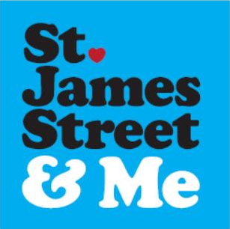
Annual Review Year 1
March 2014 to March 2015

by Fiona
for Steering Group Meeting on 2nd March 2015

Background
The St James Street area of Walthamstow is home to about 5000 people and was announced as a Big Local area in December 2012. Meetings began in February 2013 and developed into regular Steering Group Meetings from April 2014. Local charity Crest were appointed as our Local Trusted Organisation (LTO). Visioning events began from September 2013. A £20k Getting Started Application was submitted to Local Trust in December 2013 and the funds were released in March 2014. Steering Group volunteers organised adverts, interviews, contracts and agreed payment processes to employ a Community Worker. Our first community worker, Neesha Badhan, was appointed in March 2014. Throughout this work the Steering Group has had generous support from Crest our LTO.

Pathway Step 1 – Getting People Involved
Over the last 12 months we have engaged a large number of local people via:
- Attendance at about 25 local events, visits and stakeholder meetings.
- Hosting of 6 “events” of our own (Twisted Tea Party, Jumble Trail, Link4Growth Monthly Meetings; Area Profile Schools Project, 2 week Area Profile Exhibition at The Mill and Business Marketing Training Workshop). A conservative estimate is 3000 people engaged across all 6 events).
- Delivery of 3000 paper newsletters by volunteers to all households and businesses in the mapped area.
- Stakeholder organisations engaged at meetings so far– Local Councillors; LBWF Council Officers for Community Engagement, The Mill Consultancy; Greater Anglia, Ascham Homes, Yvette Chin LBWF HLF Bid Manager and Vision On Business Consultants to LBWF HLF Shopfronts Team and Save the Children amongst others. (Full list TBC by Neesha)
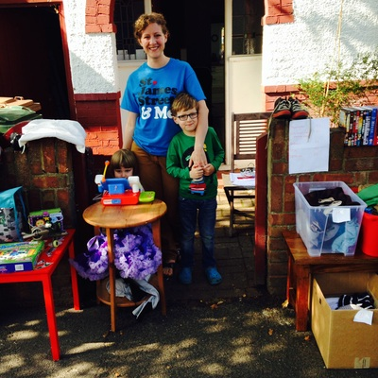
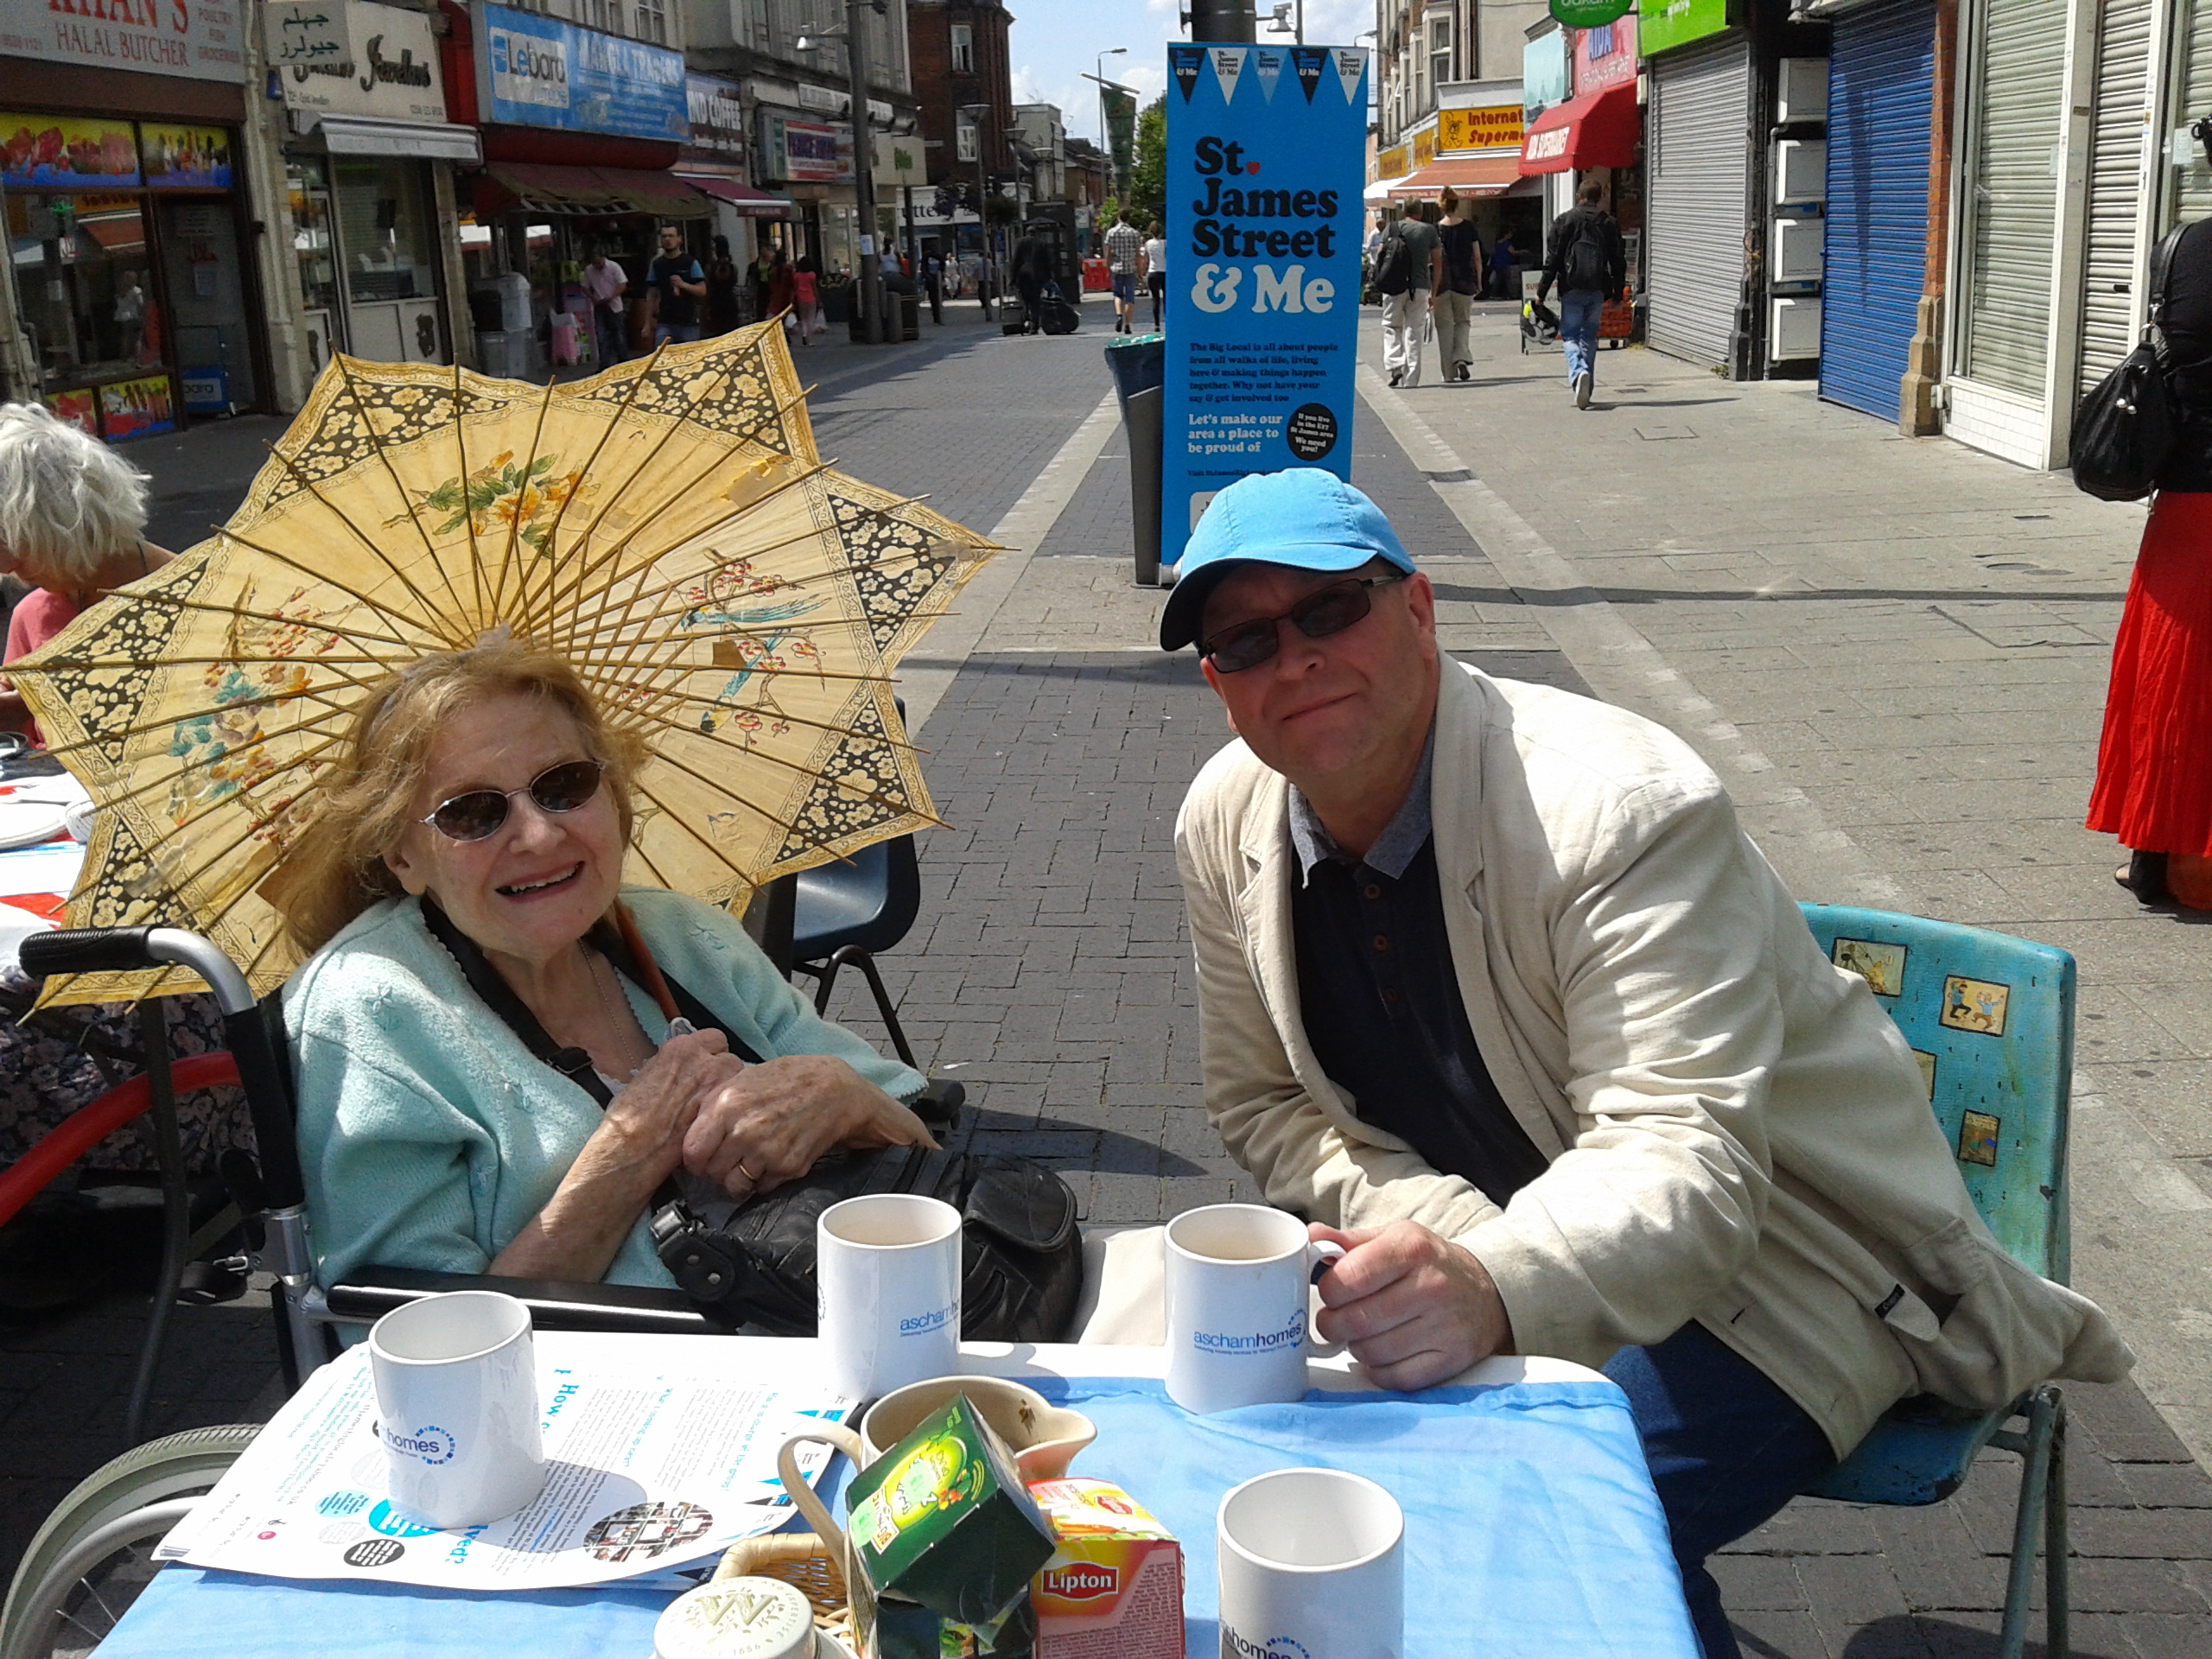

Pathway Step 2 – Exploring Your Local Vision
- Engagement targets set in 2013 were met in December 2014.
- 500 survey responses gathered as part of Phase I survey to December 2014.
- Analysis of Phase I survey by professional researcher Dan Carney identifying 9 themes of interest for the St James Street Big Local area.
- Extraction of 29 “good ideas” from Dan Carney's analysis to form basis of Phase II survey (ongoing) designed to prioritise the wishes given to us in Phase I, while still being open to new ideas. Groups identified for further engagement: BAME groups , those without internet access and residents in the southern part of the mapped area.
- Phase II survey has attracted 6300 pair comparisons to end of February 2015. 7 New ideas have been uploaded, of which only 1 is 'new': Work with LBWF to develop 1b Coppermill Lane as a pop up shop like the one on Hoe Street.
- A draft vision was agreed in January 2015:”St James Big Local's vision for the area in 2025 is that our diverse community will be living in a cleaner, greener, safer area with a reinvigorated local economy" .
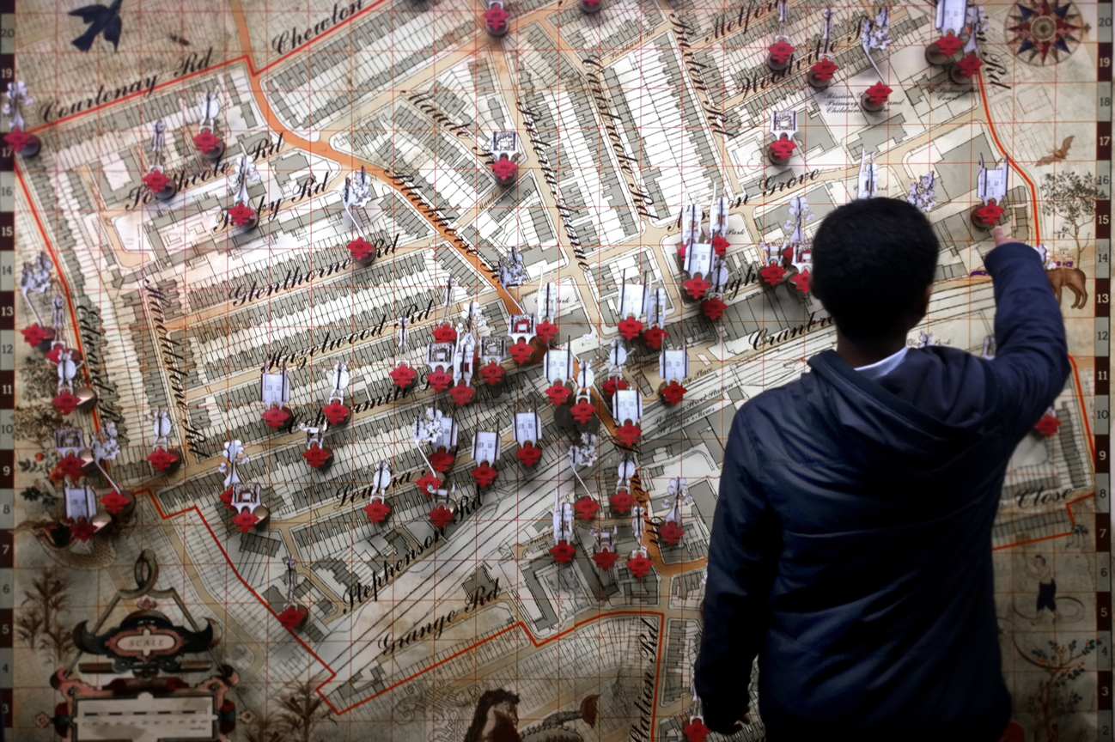

Pathway Step 3 – Forming Your Big Local Partnership
- New volunteers identified for working party and first meeting has been held.
Pathway Step 4 – Creating a Big Local Plan
- Research has begun on a few of the 29 “good ideas” to identify possible activities for the plan and partners to work with.
Pathway Step 5 – Delivering Your Big Local Plan
- Steering Group considering an application to progress Jumble Trail website to allow a second event in 2015 is being considered by the Steering Group.
Summary & Next Steps for 2015
- The St James Big Local Steering Group was perhaps too ambitious this year but progress has been excellent, with engagement targets exceeded and survey results safely organised & analysed and a Phase II (with a very large uptake) ongoing
- Pathway funding to be used to create a film(s) to explain the St James Big Local process, area profile, vision and 10 year plan by July 2015.
- Worker contract to be extended for a further 6 months to August 2015.
- Support working groups to develop Partnership models and research the 29 ideas.
- Identify the list of stakeholders to be engaged by June 2015.
Interim results from allourideas.org downloaded 25th Feb 2015 (after 8 weeks online)
Which would make the St James Street area an even better place to live?
Ideas | Current Ranking Score (0 - 100
Support the work of local volunteer-led community centre: The Mill | 73
Work to promote links with Walthamstow Marshes – both physical and visual | 70
Greening of Streets - new trees and planters in the public realm | 69
Larger scale community events eg Jumble Trail, Festival, funfair etc | 62
Support and activities for vulnerable elderly people eg. Befriending, shopping service etc. | 61
Work with the community and other partners to improve the safety and security of the area via “soft” methods | 59
Work with LBWF on the Heritage Lottery Bid to improve the shop fronts and St James Street street-scape | 57
Work with the rail operators to improve the accessibility, appearance and lighting of St James Street station. | 57
Public art | 55
Promote the idea of civic pride through activities and education, to encourage local people to better care for the St James Street area | 54
Support an established programme to help disadvantaged children improve behaviour, school attendance and academic results | 53
Support a Community Café with an ethos of access for all and sustainable living (possibly with food recycling from The High Street Market) | 53
Work with the St James Street Health Centre User Group to resolve the lease issues which are blocking improvements to their buildings | 52
Support Youth work and activities | 52
Community Chest: Small grants programme to support local people to run events and community building activities | 51
Promote a front gardens initiative (like that in Finsbury Park) | 51
Big Local Youth Panel, with a dedicated activity plan and budget, within the larger St James Big Local | 50
Work with partners, including Groundwork London, to support “friends of parks” groups and support their community building activities. | 49
Work with partners to promote volunteering, skills sharing and mentoring to benefit St James Street residents and businesses. | 48
Support Activities for over 65s | 47
Support for entrepreneurs and business start ups | 45
Promote a strong community voice by supporting volunteers to establish a St James Street “community forum”, “area lobby group” or similar | 45
Work with LBWF on the Mini Holland proposals for traffic calming, street planting and cycle facilities | 42
Work with partners to promote energy efficiency and investigate the potential for community wide regeneration schemes. | 41
Create information points – community noticeboards and online resources | 35
Work with partners to aid local businesses including support groups, help to get online and joint promotion of the local area | 35
Support the work of local charity Crest – a key supporter of St James Big Local | 29
Work with partners, including the Credit Union, to provide financial education and promote alternatives to expensive High Street lenders | 28
Work to make Big Local more transparent and inclusive | 26

